Excel Functions:

EDITED ONEE

Understanding Tabs:
Filters are in Data Tab:
Color Gradients Home Tab:

Keystrokes:
Command Z

To scroll up in excel:
- press the Command and right arrow

To scroll side to side:
- press the Command and down arrow keys

To Change Data type (Accounting, General)
- Home tab to the right of font type box

To Combine Filters:
- Select all columns (command A) or to the left of the first Column A, select the diagonal square
- Select the column you want Click Arrow, apply or remove filters
- Select other column, Ascending Descending

Freezing:
- Toolbar View Freeze Panes (top row etc)

To Freeze certain rows, columns (lets say first 3 rows)
- Click the cell in the 4th row and click freeze panes (view tab)
- So you click the row below the last row you want to be frozen

To Find something in excel/isolate data:
Select the column Data Filter Click the arrow Search what you are looking for

Creating a new column:
- Put cursor next to column you want new column to be
- Home tab Select Insert Insert Sheet Column

Deleting a Column:
- Put cursor wear you want column to be deleted
- Home Tab Under Insert Delete Sheet Column

    - Excelling with Excel:

Excel Functions:
- Organize Data
- Filter Data
- Sort Data
- Visualize Data

1.2.1 Getting Started in the Big Picture:

The data file in excel is called a worksheet, also referred to as a sheet.
It is arranged in rows and columns. Data in this format is called tabular data.

Tabular data is data that is displayed in a column and row format. This format isn't limited to Excel spreadsheets; any data displayed as a table is tabular. This includes digital tables on a website and printed tables in a textbook.

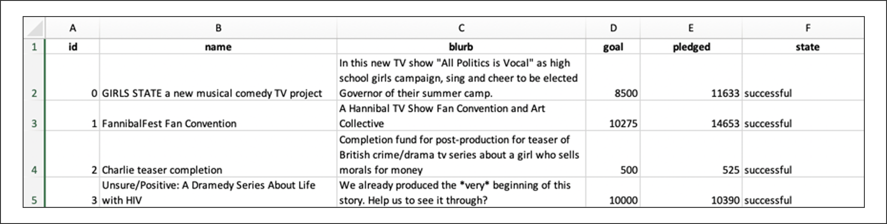

Headers and Indexes:

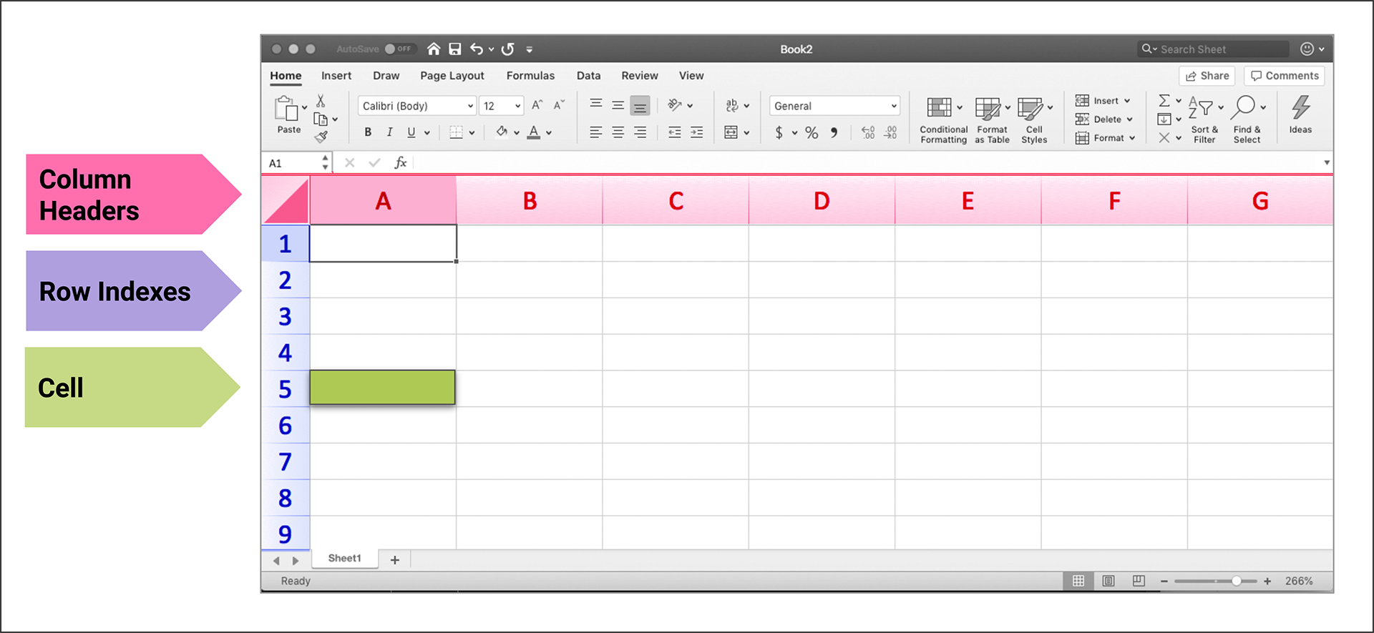

Naming & Adding Sheets:
- To create a new worksheet, click the plus sign (+).
- When multiple sheets are being used, the left and right arrows allow us to navigate between them.
- Renaming Sheet (double click the sheet at bottom of page)

Data Analysis Steps:
Step 1: Familiarize self with data
- How many columns and rows are there?
- What types of data are present?
- Is the data readable, or does it need to be converted in some way?

Step 2: Organize the Data so that it is more easily understood
- Use filters, formatting, and freezing specific columns and rows

Changing Data Formats (general accounting):
- Putting data in the correct format unlocks your ability to perform categorization, sorting, statistics, and other operations.
- When reformatting (to general, currency, accounting) format an entire column not one cell
- To select a whole column, select the head of column and command A

Is Data Readable (Timestamps):
- Locate columns I and J. They’re time stamps but not formatted correctly. Use timestamp converter tool to confirm they are timestamps
- Next step would be to reformat timestamps to dates
- Common Issue in analytics is data that needs to be converted to make it readable.

1.2.3 Filtering, Formatting, and Freezing:

What are Filters:
- Allow us to display only the specific data that we want to focus on.
- make the data far more user-friendly.
- Single out or omit data

Steps to Apply Filter:
- Select the column
- Top of the tool bar select “data”
- Click the “filter” button
- With the down arrow, apply filters.

Resetting all Filters:
- Click the "Sort & Filter" button at the top right of the Excel window.
- Click Clear
- Excel tells us which columns are sorted (filtered) change the down arrow icon to a filter or arrow icon, depending on how the data was adjusted.

Break down of Info of Louise’s Kickstarter Campaign:

- The Goal column tells us how much money each campaign will need to succeed.
- The Pledged column tells us how much each campaign actually made.
- The Outcomes column tells us if the campaign met its goal.
- The Country column lists the country in which the campaign was started.

Prompt 1:
Louise estimates that her play will cost $12,000,
- use data from the Pledged column to research projects with a similar monetary goal.
- use filters to apply this customization.

To Combine Filters:
- Select all columns (command A) or to the left of the first Column A, select the diagonal square
- Select the column you want Click Arrow, apply or remove filters
- Select other column, Ascending Descending

Prompt 1 Example Louise:
Combine filters by looking for the highest successful goal:
- Select all columns
- Select Column F “Outcomes” Remove all Select Successful
- Select Column D “Goal” Select Descending (highest # at top)
- Answer 400,000 is the highest successful outcome

Scientific Notation:
- Scientific notation is a method for displaying very large or very small numbers in a more compact way.
- Excel automatically adjusts those large or small numbers to fit within a column.
- For example, the number 3E+07 can also be displayed as 3x10^7^. This is scientific notation for 30,000,000. This means that the number starts with a 3 and has an exponent of 7 (seven zeros).
- Note that if you are using a larger monitor, then the column may not be presented as scientific notation and is already in a normal numeric format.

Freezing:
- A feature of Excel that allows portions of a spreadsheet, such as a row or column, to be locked in place so that it is always displayed, no matter what part of the sheet we're looking at.
- When a column and row are frozen together, they become a pane

Pane Freeze:
*Note one of these steps alone is a “freeze”

Step 1:To freeze top row:
- Scroll to top of excel sheet
- Click view at top of tool bar
- Freeze Top Row

Step 2:
- Repeat step 2
- Click on first cell/row you want to freeze
- Click View
- Freeze First Column

To Freeze certain rows, columns: (lets say first 3 rows)
- Click the cell in the 4th row and click freeze panes (view tab)
- So you click the row below the last row you want to be frozen

1.2.4 Conditional Formatting:

Conditional Formatting:
- Refers to customizing the appearance of a cell based on its value.
- Example: Blue = failed campaign Red = successful campaign

Conditionals in Code:
- When coding, they are referred to as conditional statements because they are paired with keywords such as if, and, and or.

Conditional Steps:
- Highlight column you want (in this case F, outcomes)
- Click conditional Formatting button in toolbar
- Select Highlight Cell Rules
- Select Equals to
- Change “Cell Value” to Specific Text, and enter the word you want to be associated with highlight “ex: live, successful, failed”
- Change format with Custom Choose color Click Ok

1.2.5 Finding Averages:

Prompt 2:
Many of the campaigns missed their goal amount by a small margin. Instead of looking at both the Goal and Pledged columns to determine the deficit, let's create a new column that contains this information.

Round formula:
- Is used to determine how much of the campaign's goal was met (prompt 2)
- Data from the Pledged and Goal columns will be used to find the percentage funded.

Round Formula Code Steps to Find Averages:

Step 1: Create new Column
Creating a new column:
- Put cursor next to column you want new column to be
- Home tab Select Insert Insert Sheet Column

Step 2:
In the first empty row of our new Percentage Funded column, enter =ROUND(E2/D2*100,0) into the cell (cell 2).
- This is our first row of data, which begins on row 2. The very first row, the header row, is row 1.

Dylan Tip:
Enter in the code for the first cell in percentage funded column. Then click and drag downwards the little green box to the remainder of the column. This will automatically edit the above code to the corresponding row/column. The easiest way to find averages to enter in the code in the first cell and double click the little green box.

Understanding =ROUND(E2/D2*100,0) Formula:
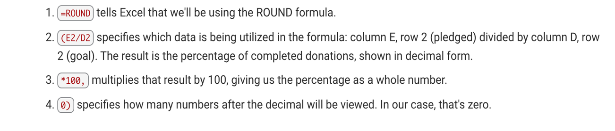

Reminder:
Creating a new column:
- Put cursor next to column you want new column to be
- Home tab Select Insert Insert Sheet Column

Deleting a Column:
- Put cursor wear you want column to be deleted
- Home Tab Under Insert Delete Sheet Column

Value Shading:

- Highlight the Percentage Funded column in the worksheet
- Home Tab Conditional Formatting Color Scales More Rules
- Select colors based on the lowest and highest values. The colors will automatically change based on the cell's value.

Elena Tip:
Use the same steps from Value Shading:
Edit the current rule adjust the Maximum Type to Percentile

#DIV/0! :
- When scrolling through the Average Donation column, you notice an error occurring: #DIV/0! Our formula is the same for every cell, so why might this error occur?
- Answer: Dividing by 0 is not allowed.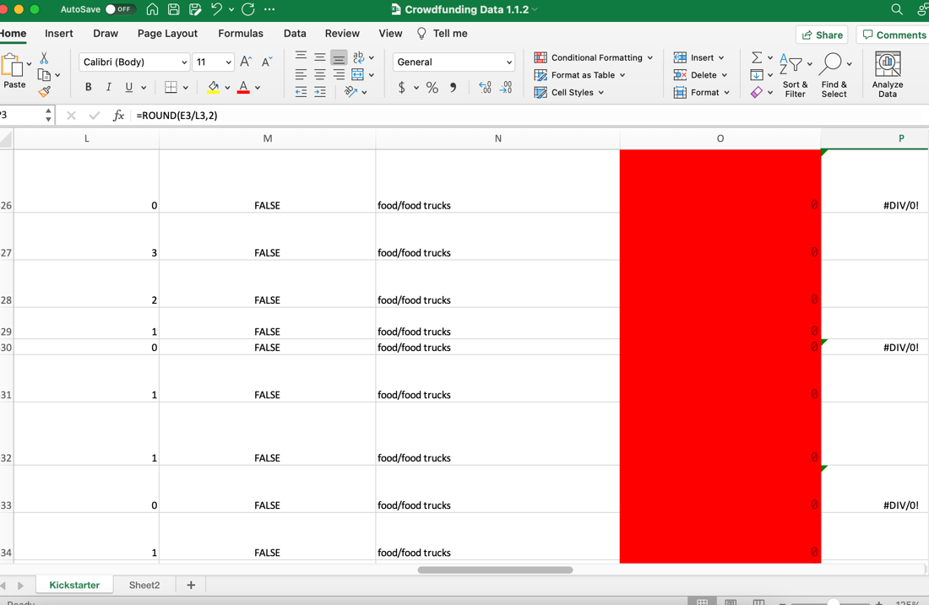

1.2.6 Errors and Debugging:

Division Error:

Problem:
- You will see this message to the right of the column#DIV/0!
- This error occurs because numbers are not divisible by zero.

Solution:
- Use code in first cell in column you want code to be entered
- =IFERROR(ROUND(E2/L2,2),0)
- Double click little square green box to apply to remainder of column

Creating Subcategories:

- Select the "Category and Subcategory" column.
- Copy the column (Command+C)
- Paste the data into the next empty column Command V
- Click the Data tab.

Adding Text in Excel:
- Click the "Text to Columns" button.
- The "Convert Text to Columns Wizard" appears.
- Inside the "Convert Text to Columns Wizard:"
  - Select "Delimited" and click "Next."
  - Uncheck the "Tab" box and check "Other."
  - Place a backslash ( / ) in the box, then click "Next."
  - Select "Text" from the "Column data format."
  - Click "Finish."

Pivot tables:
- A powerful Excel tool that condenses data into a summary that delivers information based on our questions
- Pick and choose the data we want to analyze
- Tweak it with visual customizations
- Tweak the view by filtering our chosen data after it's been set to a graph

Ask these questions when creating Pivot Tables:
- Which data do we want to see summarized?
- How do we want the data to be presented?

Steps to Creating Pivot Table:

- Click Insert Tab
- Click Pivot Table button
- “Select a table or range”, “New Worksheet”
- To the right, scroll through the “Pivot Table List” select Outcomes
- Drag “Outcomes” into the “Columns” section
- Scroll to find “category”, drag into “rows” section
- Find outcomes again, drag into the “values” section
- Find “Country”, drag into “Filters” section

(Note, for my pivot table, I chose Parent Category)

Pivot Chart:
- Complement pivot tables by using table data to create visualizations
- Ex: bar charts and line graphs
- Visualizations aid in uncovering a link or trend

Charting Subcategories:

Prompt 3:
We're using subcategories to focus our analysis on an area that is more relevant for Louise: “theatrical productions”.

- Click the Insert tab.
- Click the PivotTable button.
- Keep the default range selection and place the PivotChart in a new worksheet. Click OK.

Tip: The default range includes the entire worksheet, unless there is already a highlighted
section. Make sure there are no sections highlighted before completing this step.

- Name the new sheet Subcategory Statistics and relocate it to the right-most sheet tab (if it isn't there already).
- Drag and drop the following:
  - Country and Parent Category to Filters
  - Outcomes to Columns
  - Subcategory to Rows
  - Outcomes to Values

Note: In some later versions of Excel, Outcomes should be dragged to "Legend (Series)" and Subcategory should be dragged to "Axis (Categories)."

- Click the PivotTable Analyze tab and then click PivotChart.
- Click on the graphic to make sure it is selected, then click the Design tab at the top of the screen and select Change Chart Type. Choose Column followed by Stacked Column.
- (Optional) Customize the chart colors and grid.

1.3.3 Timing Success

Analyzing Time in Data (Questions to Ask):
- Does length of a campaign makes a difference in determining its success?
- Is a shorter or longer campaign more effective?
- Is there a certain time of year when campaigns tend to be more successful?

Prompt 4:
- Focusing on Deadline and Launched_at columns
- This column contains Unix timestamps, which measure time as the number of seconds

1.4.1 Extra Filters:

Filter Charts (Subcategory Statistics Sheet)
- In Row Labels on Excel Sheet click arrow next to header to filter:
- Click the "Select All" button to deselect everything. Scroll through the list to select only "theater."
Repeat these Steps but Change:
- In the "Subcategory Statistics" sheet, we'll select Plays.
- In the "Outcomes Based on Launch Date" sheet, we'll select "theater" for the parent category.

Findings:
- Just by glancing at the data, we can determine that theater is a popular and successful type of campaign overall

VLOOK-UP:
- lets us pull specific columns from our main dataset into a new sheet without having to search for each column and then copy and paste the data.
- we can pull only the data points we're interested in.
- VLOOK UP Formula: =VLOOKUP(A2, Kickstarter!B:C, 2, FALSE)

=VLOOKUP(A2, Kickstarter!B:C, 2, FALSE)

=VLOOKUP(A2, Kickstarter!B:E, 3, FALSE)

=VLOOKUP(A2, Kickstarter!B:E, 4, FALSE)

(Change “A2” to proper row. Next would be A2, A3, etc)
The “2 3 and 4” Are taking value from the specified column (3rd column, 4th column etc)
*Dragging down square box works too, not double clicking*

Question: Could not figure out formula to obtain info for skill drill:
In column E, use VLOOKUP to search for the average donation. Then, in column F, use VLOOKUP to search for the number of backers.
1.5.1 Measures of Central Tendency

Data Set:
- Focus of a data set is how the data is distributed
- Are data points clustered around one value, or is the data more spread out?

Measures of Central Tendency:
Central tendency refers to the tendency of data to be toward the middle of the dataset. The three key measures of central tendency are the mean, median, and mode.

The Mean is the sum of the data divided by the number of data points.

The Median answers the question "Where is the midpoint of the data?" Also known as the 50th percentile, the median is the value that splits the data into two equal halves: 50% of the data is lower than the median, and 50% of the data is higher. To calculate the median, sort the data points in order, and then locate the point in the middle.

The Mode answers the question "What value shows up the most?

When the mean and median are close to each other, the data is roughly Symmetric

If the mean is significantly different than the median, the data is Skewed, meaning that some number of extreme values are pulling the mean higher or lower

If the mean is much higher than the median, the data is skewed to the right.

If the mean is much lower than the median, the data is skewed to the left.

Measures of Spread:
Include range, variance, standard deviation, and quartiles.

The Range is the difference between the maximum value of the dataset and the minimum value of the dataset.

Variance is a measure of how far data points are from the center, or mean. To calculate the variance, do the following:
- Find the mean
- Subtract the mean from each data point.
- Square the difference so that it's positive.
- Take the average of those squared differences.

To get the unit to match, we take the square root of the variance to standardize it, or get the standard deviation. Standard deviation is often represented with a lowercase sigma (σ). You'll also see variance represented as the standard deviation squared (σ^2^)

Another method for measuring the spread is to calculate the interquartile range. After organizing the dataset from lowest value to highest value, we can break it into four separate parts known as quartiles.

Like medians, quartiles are percentiles. The lower quartile is the 25th percentile, that is, 25% of the data is less than the lower quartile. Similarly, the upper quartile is the 75th percentile, so 75% of the data is less than the upper quartile. You may also see these referred to as the 1st and 3rd quartiles. (The 2nd quartile is the median, so that one already has its own fancy name).

The difference between the upper and lower quartiles is known as the interquartile range (IQR). The IQR gives us a sense of how far out you can go from the mean to get 50% of the data.

Determining the interquartile range is done with the following formula:
IQR = Q3 -- Q1
That is, the IQR is equal to the third quartile minus the first quartile. When used to describe a list of data, the IQR tells us how the data is spread around the median

